
Green University of Bangladesh
Department of Computer Science and Engineering (CSE)
Faculty of Sciences and Engineering
Semester: (Fall, Year: 2025), B.Sc. in CSE (Day)

Lab Report NO: 02
Course Title: Web Programming Lab
Course Code: CSE 302
Section: 232-D2

Lab Experiment Name: Implementation of a Table in HTML

Student Details

Name |  | ID
1. | Ashab Uddin | 232002274

Lab Date : 15/10/2025
Submission Date : 21/10/2025
Course Teacher’s Name : Feroza Naznin

Lab Report Status
Marks: ………………………………… Signature:.....................
Comments:.............................................. Date:..............................

1. INTRODUCTION
In this lab, a seminar schedule table was created using HTML to display information in an organized format. The table includes multiple rows and columns to show the seminar days, schedule timings, and topics clearly. This task helped me understand how to use HTML table elements such as <table>, <tr>, <th>, and <td> to present structured data neatly on a web page.

2. OBJECTIVES
- To design and create tables using HTML.
- To understand and apply the concepts of rowspan and colspan for merging table cells.
3. PROCEDURE
- Start with <!DOCTYPE html> and basic HTML structure (<html>, <head>, <body>).
- Add metadata and title inside <head>.
- Use <style> to center all text in the page and table.
- Create a <table> with a border.
- Add header rows using rowspan and colspan for merged cells.
- Insert data rows for Monday, Tuesday, and Wednesday with seminar times and topics.
- Close the table and HTML tags.

4. IMPLEMENTATION

Source code
<!DOCTYPE html>
<head>
<meta charset="utf-8">
<meta name="viewport" content="width=device-width, initial-scale=1">
<style>
body {
text-align: center;
}

th,td {
text-align: center;
}
</style>
<title>Table</title>
</head>

<body>
<table border="1px">
<tr>
<th rowspan="3">Day</th>
<th colspan="3">Seminar</th>
</tr>
<tr>
<th colspan="2">Schedule</th>
<th rowspan="2">Topic</th>
</tr>
<tr>
<th>Start</th>
<th>End</th>
</tr>
<tr>
<td rowspan="2">Monday</td>
<td rowspan="2">8:00 a.m</td>
<td rowspan="2">5:00 p.m</td>
<td>Introduction to XML</td>
</tr>
<tr>
<td>Validity: DTD and Relax NG</td>
</tr>
<tr>
<td rowspan="4">Tuesday</td>
<td>8:00 a.m</td>
<td>5:00 p.m</td>
<td rowspan="2" style="padding: 7px">XPath</td>
</tr>
<tr>
<td rowspan="2">11:00 a.m</td>
<td rowspan="2">2:00 p.m</td>
</tr>
<tr>
<td rowspan="2">XSL Transformations</td>
</tr>
<tr>
<td>2:00 p.m</td>
<td>5:00 p.m</td>
</tr>
<tr>
<td>Wednesday</td>
<td>8:00 a.m</td>
<td>12:00 p.m</td>
<td>XSL Formatting Objects</td>
</tr>
</table>
</body>

</html>

5. OUTPUT

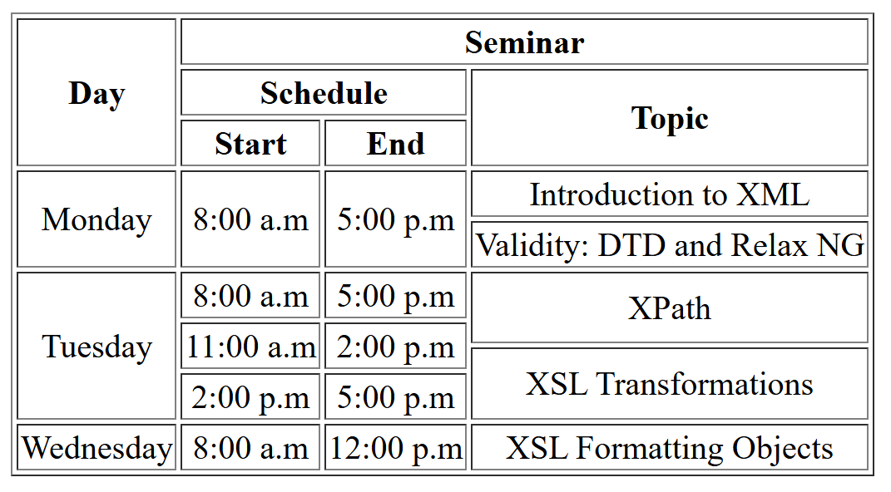

6. ANALYSIS AND DISCUSSION
In this HTML table, the <tr> tag defines a single row representing part of the Tuesday schedule. The <td> element for “Tuesday” uses rowspan="4", allowing it to extend vertically across four rows, which clearly indicates that several sessions are planned for the same day. The <td>8:00 a.m</td> and <td>5:00 p.m</td> cells specify the start and end times of the seminar, illustrating a full-day session. The <td rowspan="2" style="padding: 7px;">XPath</td> cell shows that the topic “XPath” spans two consecutive time slots, preventing repetition and keeping the table organized. The inline style padding: 7px; adds spacing inside the cell, enhancing readability. This row effectively demonstrates how combining rowspan with inline CSS can create a clean, structured, and visually appealing layout for a seminar timetable.

